Electric Vehicles vs. Gas Cars: A Comparative Analysis of Environmental Impact

Zicheng (Chance) Xu
MS Data Science, Bellevue University
DSC500: Introduction to Data Science
Professor: Matthew Metzger
Due 01/21/2024
Electric Vehicles vs. Gas Cars: A Comparative Analysis of Environmental Impact
In the contemporary automotive landscape, the streets are witnessing a surge in electric vehicles (EVs), distinguished by their near-silent operation in contrast to the audible hum of gas vehicles. Major publishers and media outlets often portray EVs as champions in environmental conservation due to their perceived lack of harmful byproducts and contributions to climate change compared to traditional gas cars. This leads to a critical question: are EVs genuinely superior to gas cars in terms of pollution prevention and environmental protection?
Utilizing Google Trends, an exploration into the public's interest reveals that the search term 'electric car environment impact' experienced a peak in April 2004, remaining robust until December 2007 (Electric Cars Environmental Impact, n.d.). Intriguingly, this heightened interest predates the official debut of Tesla, the current leader in the EV market, in 2008 (Elon Musk, n.d.). This prompts my speculation about whether public interest in the environmental impact of EVs declined after Tesla's entry into the market. It's worth noting that when I clicked on the 'help' icon above the line chart in Google Trends, it indicated that 'A score of 0 means there was not enough data for this term.' Given the presence of several terms with a score of 0, I am skeptical if there is no interest in the environmental impact of EVs for those terms, or if there was not enough data gathered.

Figure 1
electric car environment impact - Google Trend Interest over time
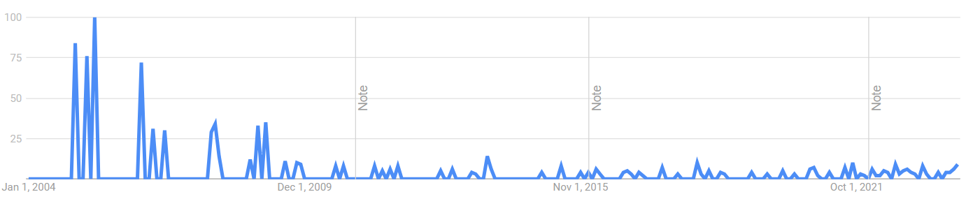
Note. The vertical line with the ‘Note’ label indicates a time when an improvement happened, such as geographical assignment or data collection system. ‘Numbers represent search interest relative to the highest point on the chart for the given region and time.’

Surprisingly, a parallel level of interest is observed when exploring the search term 'gas car environmental impact' over the same period (Gas Car Environmental Impact, n.d.), indicating a consistent concern for the environmental impact of both EVs and gas cars.

Figure 2
gas car environmental impact - Google Trend Interest over time
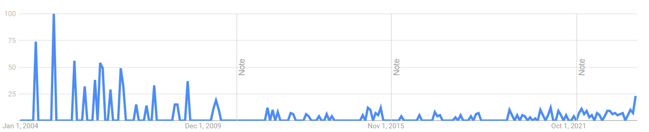

However, if we search ‘car emission’, we can find a slightly different trend over time (Car Emission, n.d.).

Figure 3
car emission - Google Trend Interest over time
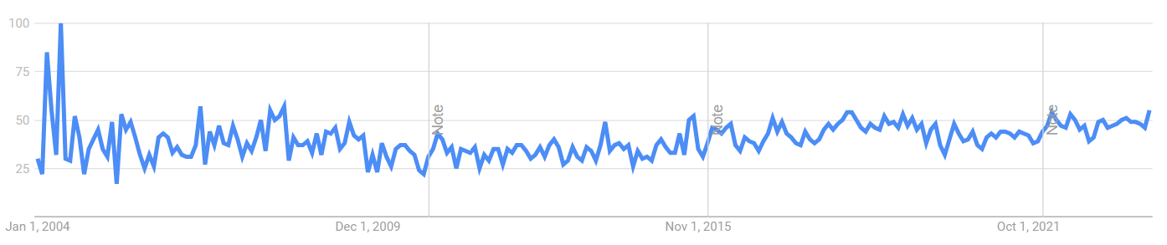

Figure 3 depicts that public interest in 'car emissions' peaked in 2004, stabilizing thereafter. A regional breakdown in Figure 4 reveals Georgia as the leading state in interest, followed by Connecticut and Utah. Notably, California, despite having the highest number of EVs, only ranks 15th (Car Emission, n.d.). Even if we narrow the time window to the past 5 years, California ranks 17th. This aligns with the assumption that in states where EVs dominate, purchasers might overlook emissions concerns, given EVs are designed to emit nothing without tailpipes.

Figure 4
car emission - Google Trend Interest by region

Note. Data applies from 2004 to the present (cut off on 12/15/2023)
According to ABI Research, a global technology intelligence firm, EVs accounted for 17.6% of total new consumer vehicle sales in 2023, meaning cars of other fuel types accounted for 82.4% of the same year. The EVs included Battery Electric Vehicles and Plug-In Hybrid Electric Vehicles, which use both batteries and other fuels such as gasoline. If only looking at Battery Electric Vehicles, the sales percentage drops to 4.5% (Global Car Sales, n.d.). A breakdown of global car sales in 2019 by fuel types from Statista shows gas car sales accounted for 78% of global car sales in 2019 (Statista, 2022). Integrating these two resources helps us show that gas car sales are dominating the market, and EVs that run purely on batteries still have a long way to go.
Despite our initial understanding of people’s interest in the environmental impact of the two different types of automobiles or car emissions in general, as well as sales volume, we still need to figure out if electric cars are better off preventing environmental deterioration than gasoline cars, as a growing number of governments are rolling out policy blueprints to phase out fossil fuels in the next decade or so (Wikipedia contributors, 2024).
To begin with, we need to understand what EVs and gas cars produce before we can quantify the difference in environmental impact on a unit basis. According to the U.S. Energy Information Administration, burning gasoline produces substances including carbon monoxide, nitrogen oxides, particulate matter, unburned hydrocarbons, and carbon dioxide, a greenhouse gas (Gasoline and the Environment - U.S. Energy Information Administration (EIA), n.d.). Based on the U.S. Department of Energy, all-electric vehicles produce zero direct emissions, which is expected (Alternative Fuels Data Center: Emissions From Electric Vehicles, n.d.).
However, that does not mean all-electric vehicles are completely ‘innocent.’ The U.S. Department of Energy points out vehicle emissions can be grouped into two general categories: air pollutants that are harmful in the form of smog or haze, and greenhouse gases. It also mentioned that tailpipe emissions are only part of a vehicle’s life cycle emissions. The electricity production, battery material refinement process, and battery recycling and scrapping process may generate emissions. A researcher from Colorado State University estimates that even factoring in emissions from mineral and metal extraction, gas cars emit approximately twice as much as EVs. Furthermore, as the EV sector decarbonizes and improves battery manufacturing efficiency, this disparity is expected to widen (Coren, 2023). The United States Environmental Protection Agency reveals a breakdown of the greenhouse gas lifecycle for both vehicle types. The estimated total greenhouse gas emission grams per mile for gas cars is approximately twice that of EVs, consistent with findings from Colorado State University (Electric Vehicle Myths | US EPA, 2023).

Figure 5
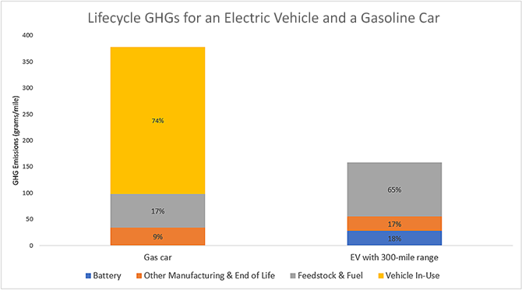
Note. Estimates. Represents model year 2020. Adapted from Electric Vehicle Myths by US EPA, 2023.

CO2 contributes to global warming because the gases in the atmosphere trap heat from the sun and stop it from going into space (Greenhouse Effect 101, 2023). Not like substances that directly cause harm to humans via inhalation such as nitrogen dioxide, CO2 causes harm to human beings by bringing more frequent and intense weather conditions such as heat waves and droughts, raising sea levels because of ice sheets melt, more insects that spread diseases, and so on. So now we know the impact of greenhouse substances gasoline cars and full-electric cars can produce, and EVs produce a lesser amount of greenhouse gases than gas cars, we need to move on to research the number of air pollutants that gas cars produce vs EVs produce throughout the car’s lifecycle to draw a firmer conclusion.
Starting with the source, Hiroshi Yamagata stated that the main materials used for traditional car engines are iron base alloys such as structural steel, stainless steel, iron base sintered metals, and cast iron and aluminum alloy parts for the piston, cylinder head, and cylinder block (Yamagata, 2005). On the other hand, the main materials used for EV battery packs are lithium, cobalt, manganese, nickel, and graphite (Slanger, 2023). As for the quantity of air pollution caused on a per-unit basis during the extraction, refinement, and transportation cycle, it is extremely hard to find reports on the internet and go into the details of the pollution related to each material’s cycle.
Alternatively, we can look at the emission from the most important part. Clarke Energy indicates that steel-making technology can be grouped into blow molding and open hearth (Clarke Energy, 2018). Converter gas created from pig iron during the steel production process consists of about 65% carbon monoxide and 15% carbon dioxide. Using this percentage as a high-level estimate and the estimate of direct CO2 emission of 1.4 tons per ton of steel produced by the International Energy Agency (Iron & Steel - IEA, n.d.), we can estimate 6 tons of carbon monoxide created per ton of steel produced. As for EVs, Govind Bhutada points out that the cells in the average battery with a 60 kWh capacity contain about 185 kg of minerals, where the top 85% are Graphite (52 kg), Aluminum (35 kg), Nickel (29 kg), Copper (20kg), Steel (20 kg). According to Statista, all of the emissions excluding CO2 from Graphite production are 99 grams per 1000 grams of graphite production (Statista, 2023). Therefore, for Graphite production, the number of all emissions without considering CO2 is negligible at a per-ton basis compared to the steel production process. I wasn't able to find data related to emissions excluding CO2 during the Aluminum, Nickel, and Copper production process, however, when including the 20 kg of steel needed for the 185 kg of minerals needed, the per ton of mineral produced will produce roughly $\frac{20 * 6}{185 }$ tons of carbon monoxide, which is far less than the 6-ton emission estimate from the steel production process. Since Arizona State University indicates steel production is among the most carbon-intensive manufacturing processes (Curtailing Unhealthy Impacts of Steel Production | ASU News, n.d.), even if we assume Aluminum, Nickel, and Copper production create the same amount of carbon monoxide as the Steel production process at a unit basis, the carbon monoxide total from producing 1 ton of mineral for the battery is 0.65 * 4 = 2.6 tons which is still far less than the 6-ton estimate during the per ton Steel production process.
Now let’s drill down to a per-car emission during the production process. Since I couldn’t find the amount of steel needed for a gas car engine or the amount of minerals needed for an EV car, I turned to look at the average engine weight and battery weight. The average engine weight per car is around 350 pounds (Niklas, 2022), whereas the average battery weight for an EV is 1,000 pounds (EVBox, 2023). Therefore, in our very conservative estimate from all the data we gathered, during the power source production process, gas cars produce 350 * 6 = 2,100 pounds of carbon monoxide, whereas EVs produce 1000 * 2.6 = 2,600 pounds of carbon monoxide.
From the tailpipe perspective, all-electric cars have zero emissions, whereas gasoline cars emit around 575 pounds of carbon monoxide per year (Document Display | NEPIS | US EPA, n.d.). That being said, it will take less than a year for gas cars to produce more carbon monoxide from usage than EV cars to make up for the 500 pounds of extra carbon monoxide produced during the EV production cycle. As the estimates are extremely conservative, we can comfortably say that EVs running only on batteries produce less carbon monoxide than gas cars.
Next, I’m looking forward to doing more research on the development of EV batteries, as the current long charging time and low endurance in cold weather still prevent a lot of people from purchasing EVs.

References
Alternative Fuels Data Center: Emissions from Electric Vehicles. (n.d.). https://afdc.energy.gov/vehicles/electric_emissions.html

car emission. (n.d.). Google Trend. Retrieved December 15, 2023, from https://trends.google.com/trends/explore?date=all&geo=US&q=car%20emission

Clarke Energy. (2018, November 10). Blast furnace, coke gas and converter gas for power production. https://www.clarke-energy.com/steel-production-gas/

Coren, M. J. (2023, September 19). Are electric cars really better for the environment? Washington Post. https://www.washingtonpost.com/climate-environment/2023/09/19/electric-cars-better-environment-fossil-fuels/

Curtailing unhealthy impacts of steel production | ASU News. (n.d.). https://news.asu.edu/20231005-curtailing-unhealthy-impacts-steel-production#:~:text=Making%20steel%20is%20among%20the,to%20the%20Environmental%20Protection%20Agency.

Document Display | NEPIS | US EPA. (n.d.). https://nepis.epa.gov/Exe/ZyNET.exe/P1009YZJ.txt?ZyActionD=ZyDocument&Client=EPA&Index=2000%20Thru%202005&Docs=&Query=&Time=&EndTime=&SearchMethod=1&TocRestrict=n&Toc=&TocEntry=&QField=&QFieldYear=&QFieldMonth=&QFieldDay=&UseQField=&IntQFieldOp=0&ExtQFieldOp=0&XmlQuery=&File=D%3A%5CZYFILES%5CINDEX%20DATA%5C00THRU05%5CTXT%5C00000027%5CP1009YZJ.txt&User=ANONYMOUS&Password=anonymous&SortMethod=h%7C-&MaximumDocuments=1&FuzzyDegree=0&ImageQuality=r75g8/r75g8/x150y150g16/i425&Display=hpfr&DefSeekPage=x&SearchBack=ZyActionL&Back=ZyActionS&BackDesc=Results%20page&MaximumPages=1&ZyEntry=2

electric cars environmental impact. (n.d.). Google Trend. Retrieved December 15, 2023, from https://trends.google.com

Electric Vehicle myths | US EPA. (2023, August 28). US EPA. https://www.epa.gov/greenvehicles/electric-vehicle-myths#:~:text=comparable%20gasoline%20vehicles.-,Myth%20%231%3A%20Electric%20vehicles%20are%20worse%20for%20the%20climate%20than,EVs)%20have%20no%20tailpipe%20emissions.

Elon Musk. (n.d.). tesla.com. Retrieved December 15, 2023, from https://www.tesla.com/elon-musk#:~:text=Since%20the%20company's%20inception%20in,SUV%2C%20which%20launched%20in%202015.

EVBox. (2023, May 24). 5 things you didn’t know about EV batteries. https://www.linkedin.com/pulse/5-things-you-didnt-know-ev-batteries-evbox#:~:text=You%20might%20have%20heard%20that,1%2C800%20kg%20(4%2C000%20pounds).

gas car environmental impact. (n.d.). Google Trend. Retrieved December 15, 2023, from https://trends.google.com/trends/explore?date=all&geo=US&q=gas%20car%20environmental%20impact

Gasoline and the environment - U.S. Energy Information Administration (EIA). (n.d.). https://www.eia.gov/energyexplained/gasoline/gasoline-and-the-environment.php

Global car sales. (n.d.). https://www.abiresearch.com/news-resources/chart-data/global-car-sales/#:~:text=EVs%20are%20consistently%20enlarging%20their,sales%20worldwide%20as%20of%202023.

Greenhouse Effect 101. (2023, June 5). https://www.nrdc.org/stories/greenhouse-effect-101#whatis

Iron & steel - IEA. (n.d.). IEA. https://www.iea.org/energy-system/industry/steel

Niklas. (2022, May 9). How much does a car engine weigh? - Weight of stuff. Weight of Stuff. https://weightofstuff.com/what-is-the-approximate-weight-of-a-car-engine/

Slanger, D. (2023, June 8). The EV battery supply chain explained. RMI. https://rmi.org/the-ev-battery-supply-chain-explained/

Statista. (2022, July 14). Car sales worldwide by fuel technology 2019 & 2030. https://www.statista.com/statistics/827460/global-car-sales-by-fuel-technology/
Wikipedia contributors. (2024, January 18). Phase-out of fossil fuel vehicles. Wikipedia. https://en.wikipedia.org/wiki/Phase-out_of_fossil_fuel_vehicles#:~:text=In%20November%202021%2C%20the%20Indian,2035%20in%20%22leading%20markets%22.

Yamagata, H. (2005). The science and technology of materials in automotive engines. Elsevier.

